

# SENSOR + TEST 2021

## DIE MESSTECHNIK - MESSE

## The Measurement Fair

**4 – 6 May 2021**

6 May 2021

Tel. +49 6131 26751-93

presse@sensor-test.com

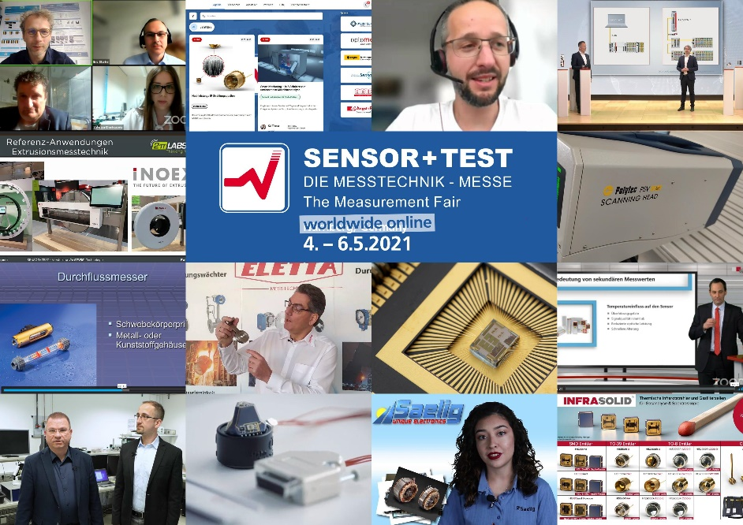

1. Download photo:

# <https://www.sensor-test.de/assets/de/Presse/Presse-Center/Bildergalerien/Fotos-2021/SENSOR-TEST-2021-digital/20210210-SENSOR+TEST-2021-Digital.jpg>

### Review Press Release

# All new, all online: SENSOR+TEST affirms its leading role – digitally as well

**Out of the company’s office or home office – over 2,500 visitors from Germany and abroad met for the Innovation Dialog as well as for the first SMSI Sensor and Measurement Science International Conference during the three days of the fair. With 188 exhibitors, the event boasts a considerable size compared to the previous digital trade fairs. Thus, the SENSOR+TEST was again able to maintain its position as the leading international event for sensor, measuring, and testing technology.**

“For us as the organizers as well as for the many exhibitors and visitors, this digital SENSOR+TEST was uncharted territory. And we’re proud indeed to have been able to completely carry out such a digital event so well. Realizing that these three days were no full-fledged substitute for a presence event, we were in a position to clearly advance and expand the digitalization of our leading fair,” said organizer Holger Bödeker.

Thus – after the first truly online event in 2020 – this year’s edition started off with a significantly improved system and a plethora of innovations, presentations, and talks as well as optimized opportunities for digital communication among all the participants.

In fact, the participants made abundant use of these opportunities not only to obtain information on the many interesting innovations at the digital trade-fair “stands,” but also to talk directly with the exhibitors’ experts via modern chat functions and to make appointments.

The focus was mainly on the series of presentations: In 50 in-depth lectures on technology and 91 short-form talks, the exhibitors presented their latest solutions and trends in sensor and measuring technology. The attendance of thousands of participants show how immensely interesting and up-to-date these innovations are.

This year’s special topic, Sensor and Measuring Technology for Condition Monitoring, was discussed with great interest. The digital-format contributions to this topic provided by the exhibitors were great public attractions. Also the community stand, Young Innovative Enterprises, was held digitally. The ten participating start-ups were also able to present their fresh ideas to the visitors via the trade-fair platform.

The number of visitors, 2,500, was as expected less than at a presence event (2019: approx. 7,000). The same is true for the exhibitor numbers, 188 (2019: 538). “We have to be satisfied with these figures in consideration of the current situation. All of us were able to gain a lot of experience during the preparation of this online fair and were anxious to see how the Innovation Dialog would fare under digital conditions. Now we can say that we were not disappointed. And we hope that all exhibitors, visitors, and conference participants were able to profit from the SENSOR+TEST,” said Holger Bödeker.

**A new era of conferences has been heralded**

The SENSOR+TEST was able to continue its long and successful tradition in hosting scientific conferences while also heralding a new era with the first parallel **SMSI Sensor and Measurement Science International Conference** (3 – 6 May 2021). Over 220 participants attended 167 presentations, tutorials, and discussions. The new format packed a scientific punch, as linked up national and international representatives from research, science, and industry. Thus, the SMSI provided a platform for the exchange of future-oriented research results. A pioneering science slam allowed young scientists to show off their innovations in unusual, but entertaining ways. This they did smoothly and very successfully.

The next SMSI conference will be held in 2023 – again parallel with the SENSOR+TEST.

**SENSOR+TEST 2022: Real, virtual, and hybrid**

Next year the SENSOR+TEST is to be held again as a presence event from 10 to 12 May in the halls of the Nuremberg Exhibition Center. Complementing this event is a digital part to take place beyond the three day of the fair during the entire year in which novelties from the exhibitors will be broadcast in various channels. “This should create an ideal link between both worlds and help to advance next year’s event. Thus, the SENSOR+TEST will continue to be a hybrid event in the future,” explained Holger Bödeker.

On the science side, the 2022 fair will be complemented by the 21. ITG/GMA-Fachtagung Sensoren und Messsysteme. And **Sensor and Measuring Technology for Digitalization** is to continue the long series of special topics dealing with a future-relevant and exciting topics for exhibitors, visitors, and online participants.

“Nobody can say now under what external conditions exhibitors and visitors can hopefully come together again in person next year in Nuremberg. For us, this is top priority as many of our participants want nothing more than to be together again at a real fair, face to face – and we’d love to invite you,” says Holger Bödeker. Peter Krause, CEO of PRIGNITZ Mikrosystemtechnik and chairman of the AMA Association for Sensors and Measurement, is also looking ahead to 2022. “This was our first digital trade fair. It was nice to talk and exchange ideas, but we look forward to the next presence fair.”

**Press contact:**

AMA Service GmbH

Von-Münchhausen-Straße 49, 31515 Wunstorf, Germany

Dirk Schaar

Phone +49 6131 26751-93, presse@sensor-test.com

Further press texts and photos of the SENSOR+TEST can be downloaded free of charge for journalists at [www.sensor-test.com/press](http://www.sensor-test.com/press).

**You can also follow us on the social media:**

**Twitter:** <https://twitter.com/sensorplustest>

**Facebook:** <https://www.facebook.com/sensorplustest/>

**LinkedIn:** <https://www.linkedin.com/company/sensor-test/>

**Xing:** <https://www.xing.com/events/sensor-test-2020-messtechnik-messe-2132609>

**Youtube:** <https://www.sensor-test.de/direkt/youtube>