

# SENSOR + TEST 2021

## DIE MESSTECHNIK - MESSE

## The Measurement Fair

**4 May 2021 – 6 May 2021**

20 April 2021

Tel. +49 6131 26751-93

presse@sensor-test.com

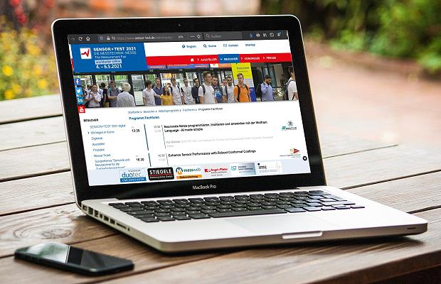

1. Download Photo:

# <https://www.sensor-test.de/assets/de/Presse/Presse-Center/Bildergalerien/Fotos-2021/SENSOR-TEST-2021-digital/20210210-SENSOR+TEST-2021-Digital.jpg>

### Press Release

# SENSOR+TEST Digital 2021 is at the Ready

**Two weeks before the start of the Digital SENSOR+TEST from 4 to 6 May 2021, the preparations are running at full speed. More than 160 exhibitors are to present their latest achievements in sensor and measuring technologies during and after the trade fair. The participants can expect a comprehensive presentation program with exciting and in-depth technical talks.**

“We’re on the home stretch and looking forward to the Digital Innovation Dialog among exhibitors and participants which is being offered again this year in all its facets by the SENSOR+TEST. Even if we don’t reach the size of previous presence events, we’ll still have over 160 exhibitors, who’ll have plenty of solutions among wide-ranging applications to offer the public,” says organizer Holger Bödeker.

The exhibitors are showing a plethora of innovative developments this year – and not just in text and images, but also in numerous video presentations with direct contact to the speakers per chat or video conference. Visitors can link up with experts per apps or internet portals, taking advantage of their consulting competence.

A variety of novelties can already be regarded. Thus, there are already more than 250 new developments on the SENSOR+TEST website (<https://www.sensor-test.de/direct/productnews>) – and every day there are more. So it is worth it to take a good look – during and after the fair.

**Comprehensive Action Program**

As expected from the SENSOR+TEST, visitors will find a comprehensive action program even in this digital edition. In the lecture forum, exhibitors are to present new developments, products, and applications on all three days of the fair. Even this year’s special topic, “Sensor and Measuring Technology for Condition Monitoring,” and the digital community stand, “Young Innovative Enterprises,” will not come up short. “Whether it’s about the special topic, presentations, the AMA Innovation Award, or the parallel SMSI, the Sensor and Measurement Science International Conference: The participants expect information and inspiration from all sides and in-depth,” says Holger Bödeker.

**Entrance Vouchers Available Now**

As of now, visitors can obtain a free entrance voucher. Registration takes place at [www.sensor-test.com/voucher](https://www.sensor-test.com/voucher). “We’re cordially inviting all interested parties to the digital edition of the SENSOR+TEST 2021. Be sure to register and get into the Innovation Dialog with the experts. Follow all the activities of the exhibitors and lecturers in our internet portals, per newsletter, or in the social-media channels. Though even if you can’t touch the technology on site this year, I’m certain that all participants will obtain all the important information necessary for their projects and also make new valuable contacts,” says Holger Bödeker.

Before publication we ask for publishing confirmation or a link.

**Press contact:**

AMA Service GmbH  
Von-Münchhausen-Str. 49, 31515 Wunstorf, Germany

Dirk Schaar  
Tel. +49 6131 26751-93, [presse@sensor-test.com](mailto:presse@sensor-test.com)

Further press texts and photos of the SENSOR+TEST can be downloaded free of charge for journalists at [**www.sensor-test.com/presse**](http://www.sensor-test.com/presse).

**You can also follow us on the social media:**

**Twitter:** <https://twitter.com/sensorplustest>

**Facebook:** <https://www.facebook.com/sensorplustest/>

**LinkedIn:** <https://www.linkedin.com/company/sensor-test/>

**Xing:** <https://www.xing.com/events/sensor-test-2020-messtechnik-messe-2132609>

**YouTube:** <https://www.sensor-test.de/direkt/youtube>