

# SENSOR + TEST 2021

## DIE MESSTECHNIK - MESSE

## The Measurement Fair

**4–6 May 2021**, Nuremberg**,** Germany

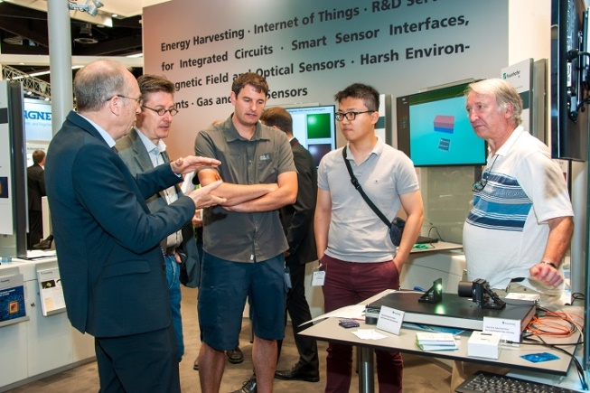

1 December 2020

Tel. +49 6131 26751-93

presse@sensor-test.com

<https://www.sensor-test.de/assets/de/Presse/Presse-Center/Bildergalerien/Fotos-2019/Messegeschehen/SENS+Test-2019-1237.jpg>

### Press Release

# SENSOR+TEST 2021: Real, Virtual, and Hybrid

**“Although the experts were not allowed to meet for a concentrated exchange at the worldwide most important industrial trade fair for sensor and measurement technologies this year, the SENSOR+TEST still is the leading fair of this branch of industry,” says Holger Bödeker, the managing director of AMA Service. His team is already planning the next event to take place from 4 to 6 May 2021 for exhibitors and visitors to the innovation dialog at the Nuremberg Exhibition Center. Moreover, the SENSOR+TEST will boast hybrid configurations and a novel Digital Area.**

The program is supposed to be packed again: Thus, the special topic planned for 2020, **Sensor and Measuring Technology for Condition Monitoring**, will be held in 2021. The organizer and the exhibitors’ committee approved this as the special forum was received with great interest for 2020 and booked out early. The second highlight is the presence and digital premiere of the **SMSI – Sensor and Measurement Science International Conference**, which is to open its doors the day before the SENSOR+TEST and will include the presentation of the AMA Innovation Award.

“This event is going to start with a high quality even if we as the organizer have to assume a somewhat more compact presence trade fair due to corona,” stated Holger Bödeker. Whether international visitors are allowed in Germany in May of 2021 needs to be seen. “We will adapt the SENSOR+TEST to whatever conditions exist, while ensuring that both, exhibitors and visitors, can look back with satisfaction on the three days of the fair. Also, we’re going to make sure that a constantly accessible platform for an exchange of ideas is available.” The basis for this concept is a tripartite model expanding on the presence event in a digital world:

**Real:** This is where exhibitors and visitors maintain their indispensable personal contacts on the trade-fair grounds.

**Virtual:** Here we have year-round, continuous digital communication between exhibitors and visitors as initiated in 2020.

**Hybrid:** This feature enables all participants at the SENSOR+TEST 2021, present on site or digitally via the internet, to interact with each other.

**Digital Area advances dialog**

Exhibitors will profit from the new format of the SENSOR+TEST. By merely booking a stand they will automatically participate in the digital fair. This has the advantage that both, the visitors in Nuremberg as well as the digital participants can take part from all over the world. Moreover, their digital presence until the end of the year 2021 will be constantly available. This aspect is complemented by the new Digital Area – without the necessity, but with the opportunity, of being on site ([www.sensor-test.de/direct/digitalarea](http://www.sensor-test.de/direct/digitalarea)): Here, enterprises can present themselves at many levels to interested parties – via multimedia presentations of product novelties and via text or video chats with the trade-fair visitors or through lectures and discussion rounds. “By participating in the Digital Area, exhibitors have no risk, but all possible chances,” ensures Holger Bödeker.

“Despite the economic and political challenges and general changes that will accompany us in the next few months, we want to maintain the communication between exhibitors, scientists, and visitors – and that via the state-of-the-art channels available to us today. That’s what the SENSOR+TEST is about this coming year and the future,” affirmed Holger Bödeker.

Further information on the numerous opportunities to participate at the trade fair at <www.sensor-test.com>.

Before publication we ask for publishing confirmation or a link.

**Press contact:**

AMA Service GmbH

Von-Münchhausen-Str. 49, 31515 Wunstorf, Germany

Dirk Schaar

Tel. +49 6131 26751-93, [presse@sensor-test.com](mailto:presse@sensor-test.com)

Further press texts and photos of the SENSOR+TEST can be downloaded free of charge for journalists at [**www.sensor-test.com/presse**](http://www.sensor-test.com/presse).

You can also follow us on the social media:

**Twitter:** <https://twitter.com/sensorplustest>

**Facebook:** <https://www.facebook.com/sensorplustest/>

**LinkedIn:** <https://www.linkedin.com/company/sensor-test/>

**Xing:** <https://www.xing.com/events/sensor-test-2020-messtechnik-messe-2132609>