**4 to 6 of May 2021**, Nuremberg**,** Germany



# SENSOR + TEST 2021

## DIE MESSTECHNIK - MESSE

## The Measurement Fair

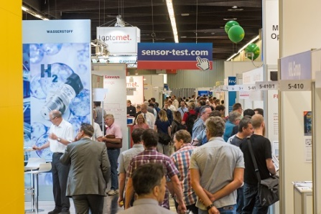

12 October 2020

Tel. +49 6131 26751-93

presse@sensor-test.com

### <https://www.sensor-test.de/assets/de/Presse/Presse-Center/Bildergalerien/Fotos-2019/Erste-Impressionen/SENS+Test-2019-0406.jpg>

### Press Release

# SENSOR+TEST 2021: Numerous Exhibitors Despite Corona Virus Early-Bird Deadline until 31 October

Since the SENSOR+TEST trade fair was not allowed to take place in 2020, we have started planning for the next event. From 4 to 6 May 2021 experts will be meeting again for an in-depth exchange on the worldwide most important industrial fair for sensor and measuring technology.

Great interest is shown by the exhibitors only seven months before the fair is to be held – despite the uncertain outlook due to the Corona pandemic. “The halls are already filling up, many enterprises want to use the opportunity to exhibit again in Nuremberg and thereby to take their spot at the digital SENSOR+TEST as well,” says Holger Bödeker, the managing director of AMA Service.

So all who want to participate as exhibitors at the next SENSOR+TEST from 4 to 6 May 2021 in a good pole position should act soon. Enterprises that make a firm booking until 31 October 2020 will not only profit from the particularly favorable conditions, but also from an attractive early-bird discount on the basic stand rent. Moreover, every exhibitor will also participate in the digital fair at no extra charge. “Thus, for a very reasonable price, enterprises can make use of the presence fair for the innovation dialog as well as the year-round digital channels,” adds Holger Bödeker on the advantages of participating at the SENSOR+TEST 2021.

Application forms and further information on the many options for an exhibitor participation can be found at [www.sensor-test.com](http://www.sensor-test.com).

Before publication we ask for publishing confirmation or a link.

**Press contact:**

AMA Service GmbH

Von-Münchhausen-Str. 49, 31515 Wunstorf, Germany

Dirk Schaar

Tel. +49 6131 26751-93, [presse@sensor-test.com](mailto:presse@sensor-test.com)

Further press texts and photos of the SENSOR+TEST can be downloaded free of charge for journalists at **www.sensor-test.com/presse**.

You can also follow us on the social media:

**Twitter:** <https://twitter.com/sensorplustest>

**Facebook:** <https://www.facebook.com/sensorplustest/>

**LinkedIn:** <https://www.linkedin.com/company/sensor-test/>

**Xing:** <https://www.xing.com/events/sensor-test-2020-messtechnik-messe-2132609>