

# SENSOR + TEST 2020

## DIE MESSTECHNIK - MESSE

## The Measurement Fair

**23–25 June 2020**, Nuremberg**,** Germany

25 September 2019

Tel. +49 5033 9639-0

Fax +49 5033 9639-20

### Press Release

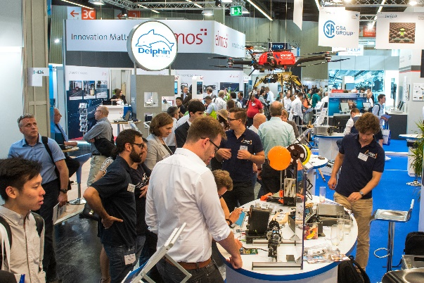

### [assets/de/Presse/Presse-Center/Bildergalerien/Fotos-2019/Messegeschehen/SENS+Test-2019-0360.jpg](https://www.sensor-test.de/assets/de/Presse/Presse-Center/Bildergalerien/Fotos-2019/Messegeschehen/SENS+Test-2019-0360.jpg)

# SENSOR+TEST 2020: New Hall Combinations Buff Up Trade Fair Early-Bird Deadline 31 October 2019

“The SENSOR+TEST is just the fair to give you an ideal overview of sensor and measuring technology. Compared to other events, we were able to make a lot of contacts here and establish successful business ties. No technical professional, who is looking for sensors or measuring technology, can get around a visit to the SENSOR+TEST,” says Bernd Jödden, managing director of a.b.jödden gmbh, talking about his positive experience of many years. Like him, many exhibitors have booked their regular spot – or a favorite location in the new Hall 3C – at the leading international fair for sensor, measuring, and testing technology in Nuremberg next year. These activities were confirmed by Holger Bödeker, AMA Service’s managing director, saying, “The demand for preferred stand locations has definitely increased. The new hall configuration is a positive contribution to this effect. By integrating the new, state-of-the-art Hall 3C and the circulating passage it provides, has significantly improved options for stand planning. This will further increase the efficiency of the fair for exhibitors and visitors.”

The next SENSOR+TEST will be held from 23 to 25 June 2020 in Nuremberg, Germany – this time with the special topic “Sensors and Measuring Technology for Condition Monitoring.” Interested parties wishing to participate as exhibitors should hurry. Enterprises that book firmly no later than **31 October 2019** not only profit from a favored stand location, but also from especially advantageous conditions and an attractive early-bird discount on the basic stand fee.

Registration forms and further information on the many options for an exhibitor participations can be found at [www.sensor-test.de](http://www.sensor-test.de).

**Press contact:**

AMA Service GmbH

Von-Münchhausen-Str. 49, 31515 Wunstorf, Germany

Brita Menßen

Tel. +49 5033 9639-14, Fax +49 5033 9639-20, presse@sensor-test.com

Press texts and photos on the SENSOR+TEST can be downloaded free of charge for journalists at [**www.sensor-test.com/presse**](http://www.sensor-test.com/presse).