

SENSOR + TEST 2027

DIE MESSTECHNIK - MESSE

The Measurement Fair
11 - 13 May 2027, Nuremberg, Germany

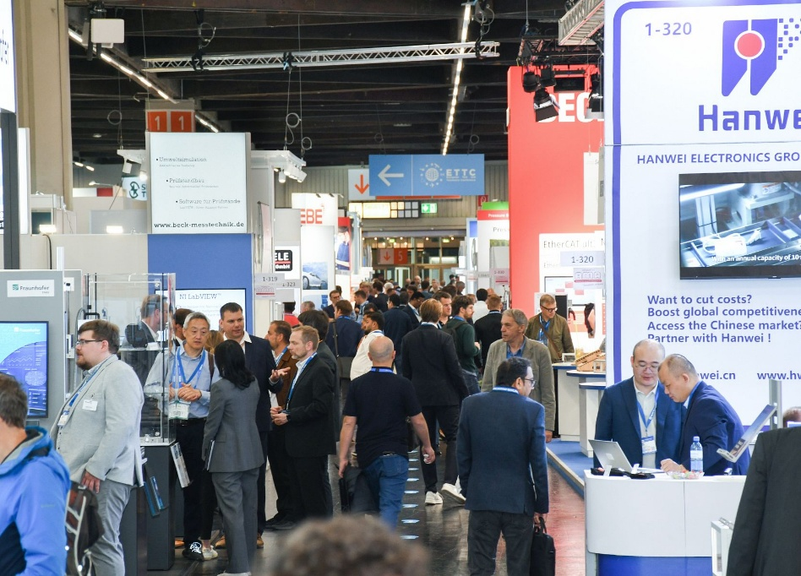

Press Release
September 23, 2026
Tel. +49 6131 26751-93
presse@sensor-test.com

SENSOR+TEST 2027: Safe Your Booth Space Now

Following the success of SENSOR+TEST 2026, preparations for the next edition are already in full swing. From May 11–13, 2027, the international sensor and measurement technology industry will once again gather in Nuremberg. Those who register by October 31, 2026, will benefit from attractive early-bird rates.

SENSOR+TEST 2026 once again underscored its importance as an international meeting place for sensor, measurement, and testing technology. The focus was on technological developments and applications, as well as the growing integration of sensor technology, data processing, software, and artificial intelligence.

Safe Your Spot Early
SENSOR+TEST brings together suppliers and users from numerous industries. The spectrum ranges from automotive, mechanical engineering, and industrial automation to aerospace, energy, medical technology, and rail.
By booking early, exhibitors can plan their trade show presence well in advance while also benefiting from more favorable rates through October 31, 2026. SENSOR+TEST’s digital channels complement in-person interactions at the event and provide a year-round presence.
“Companies can not only use the in-person trade show to engage in the Innovation Dialog with visitors, but also leverage SENSOR+TEST’s digital channels. This gives exhibitors the opportunity to showcase their technologies and solutions year-round, even beyond the three days of the trade show,” says Elena Schultz, Managing Director of AMA Service GmbH.
At SMSI 2027 – the Sensor and Measurement Science International Conference, which serves as the scientific counterpart to SENSOR+TEST 2027 – international experts from research, science, industry, and government institutions will gather to discuss the latest research findings and future trends.

SENSOR+TEST 2027 will take place from May 11 to 13, 2027, in Nuremberg. The early-bird registration period ends on October 31, 2026.

Further information about SENSOR+TEST can be found at www.sensor-test.com

Upon publication, please provide a copy of the publication or a link.

Press Contact:
AMA Service GmbH
Von-Münchhausen-Straße 49, 31515 Wunstorf, Germany

Dirk Schaar
Phone: +49 6131 26751-93, presse@sensor-test.com
Additional press releases and photos about SENSOR+TEST are available for journalists to download free of charge at www.sensor-test.com/press

Follow SENSOR+TEST on social media:
X: https://x.com/sensorplustest
Facebook: https://www.facebook.com/sensorplustest/
LinkedIn: https://www.linkedin.com/company/sensor-test/

