SENSOR + TEST 2026

DIE MESSTECHNIK - MESSE

The Measurement Fair
9-11 June 2026, Nuremberg, Germany

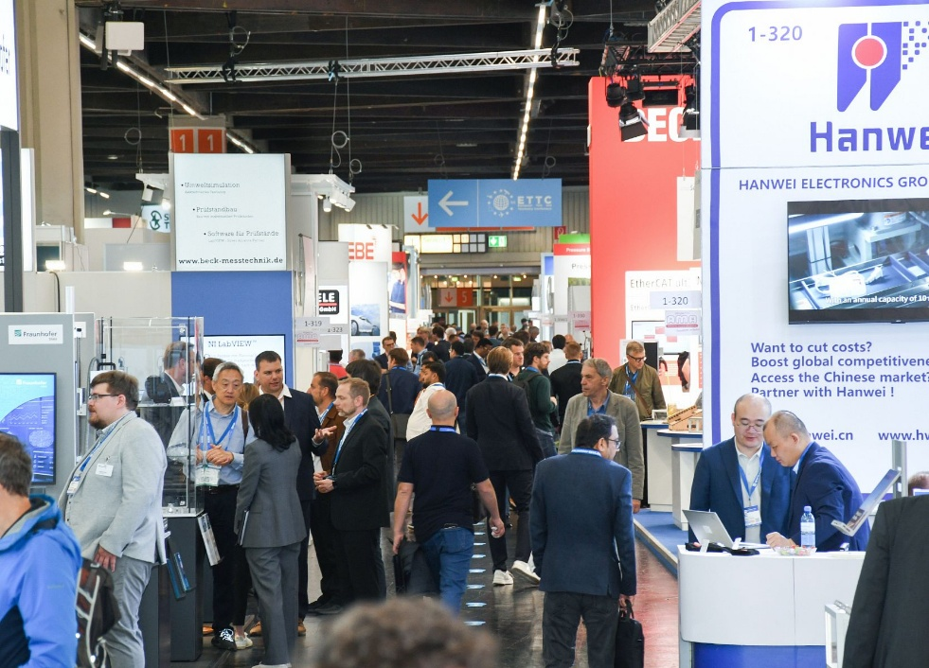

Press Release
June 11, 2026
Phone: +49 6131 26751-93
presse@sensor-test.com

SENSO SENSOR+TEST 2026 – At the Heart of Industrial Innovation

With its clear focus, SENSOR+TEST, held in Nuremberg from June 9–11, 2026, has once again confirmed its role as the leading international trade fair for sensor, measurement, and testing technology. The event brings together a unique combination of technological depth and cross-industry diversity – and it is precisely this dynamic that is its key success factor. Anyone who wants to know how measurement data shapes the future cannot afford to miss SENSOR+TEST.

Under the motto “Welcome to the Innovation Dialog,” the international sensor and measurement technology industry gathered in Nuremberg from June 9 to 11. For three days, the focus was on innovations, expert discussions, and direct exchange between industry, research, and development.

317 exhibitors from 25 countries, 4351 trade visitors, 251 conference participants, and a total of around 7000 fair attendees took advantage of the three days to discuss current developments, industrial applications, and future technology trends.
Exhibitors presented solutions that illustrate the increasing convergence of sensor technology, data processing, software, and artificial intelligence in comprehensive industrial systems.
SENSOR+TEST is regarded as the central platform for sensor, measurement, and testing technology because it not only offers visitors an overview of technologies but also provides in-depth insights into how they work, their further development, and their industrial implementation. At the same time, it covers nearly all relevant application fields – from automotive, mechanical engineering, and industrial automation to aerospace, energy, medical technology, and rail. This combination of technological depth and broad industry coverage makes the trade show unique on the international stage.
Elena Schultz, Managing Director of AMA Service GmbH, draws a positive conclusion: “SENSOR+TEST 2026 impressively demonstrated how strongly our industry is helping to shape technological change. Of particular importance is the intensive professional exchange, which goes far beyond individual products and enables a genuine understanding of the system.”
Exhibitors also emphasized the high quality of the discussions. The focus was particularly on system integration, data quality, and AI-based applications. Visitors arrived with specific questions and used the trade show specifically to solve complex technical challenges.

Technological convergence is shaping the industry
A central theme of SENSOR+TEST 2026 was the increasing convergence of sensor technology, data processing, software, and artificial intelligence. Sensors are evolving from mere measurement transducers into intelligent system components within networked industrial architectures.
The focus was on applications in predictive maintenance, smart manufacturing, robotics, autonomous systems, and data-driven quality assurance. It became clear that the decisive factor for success lies not solely in the sensor technology itself, but in the quality, structure, and availability of the data. Calibration, traceability, synchronization, and multisensor fusion came further into focus – as the foundation for robust and industrial AI applications. “We are currently not witnessing isolated technological leaps, but rather a phase of technological convergence. The future of industry will not be determined solely by algorithms, but by the quality and availability of the underlying data,” summarizes Elena Schultz.

Forum as a Platform for Knowledge Transfer
An extensive lecture program accompanied the trade fair over all three days. The open expert forum offered concise insights into new technologies, concrete applications, and current research findings.
The program was complemented by thematic areas such as Condition Monitoring and Calibration, which specifically promoted exchange between developers, users, and academia. The sessions were well-attended and underscored the need for guidance in an increasingly complex technological field.
The expert forum “AI-Supported Measurement Technology and Sensor Technology – Intelligent Systems Between Innovation, Responsibility, and Practice,” which placed Industrial AI in the context of industrial applications, received particular attention. “The strong response shows that the need for informed exchange and deep technical understanding continues to grow,” explains Elena Schultz.

Science and Industry in Direct Dialog
Accompanying SENSOR+TEST were the 23rd ITG/GMA Symposium “Sensors and Measurement Systems” and the European Test and Telemetry Conference (ETTC). Both events perfectly complemented the trade show and facilitated an intensive exchange between research, development, and industrial practice. Topics ranged from modern sensor and measurement systems to telemetry, IoT, and edge computing, all the way to AI and complex system architectures. The direct transfer of scientific findings into industrial applications was particularly valuable. “It is precisely the combination of scientific depth and industrial implementation that defines the special character of SENSOR+TEST,” says Elena Schultz.

Networking, Dialog, and New Perspectives
In addition to the technological content, personal exchange also played a central role in 2026. The trade show offered numerous opportunities for networking, collaboration, and the establishment of new project partnerships. “The newly created networking platform, in particular, made a positive contribution,” says Elena Schultz.
SENSOR+TEST thus once again proved itself to be a meeting place where products are not only presented, but technologies are understood in depth and interconnected across their full scope. “Thanks to the many new contacts we made, our trade show appearance was a success in terms of generating new projects,” said Elena Schultz. The exhibitors also confirm this.

2027: Sensor Technology as a Key Enabler of Industrial Transformation
SENSOR+TEST 2026 once again highlighted that sensor and measurement technology are among the central enablers of industrial transformation. The industry is increasingly shifting from individual technologies toward integrated, data-driven systems.
“The more complex technologies become, the more important it is to have places where they can be contextualized and further developed collaboratively. SENSOR+TEST is exactly such a place,” summarizes Elena Schultz.
The next SENSOR+TEST will take place from May 11 to 13, 2027, in Nuremberg. Preparations are already underway to further strengthen the international Innovation Dialog and once again bring the technological depth of the trade fair to life.
The successful series of parallel conferences will also continue. At SMSI 2027 – the Sensor and Measurement Science International Conference – national and international experts from research, science, industry, and government institutions will meet for the third time to present their latest research findings and exchange ideas and future trends. “With a strong program of lectures and presentations, the event will offer a glimpse into the future of our technology. SMSI 2027 thus not only provides an excellent platform for sharing the latest research findings but also features top-tier lectures, poster sessions, and a Science Slam,” says conference chair Prof. Dr. Ulrich Schmid (TU Wien), already looking forward to next year.

SENSOR+TEST continues digitally
Even after the trade show, SENSOR+TEST continues its communication efforts. Content, innovations, and technological trends remain available via the event’s digital channels such as the website, newsletter, and social media – extending the professional dialog beyond the trade show dates.

The exhibiting companies also draw a positive conclusion:

“SENSOR+TEST 2026 was once again a resounding success for us. In particular, the face-to-face interactions with customers and partners demonstrated just how valuable direct dialogue is for generating new ideas, innovative solutions, and long-term collaboration. Many thanks to all visitors – we look forward to continuing these discussions!”
Alan Ravizza, Head of Sales and Marketing and Member of the Executive Board at Innovative Sensor Technology IST AG

“Our expectations were exceeded at SENSOR+TEST 2026. We had many valuable discussions and generated many promising leads. The trade show was a complete success for us. We will be exhibiting at SENSOR+TEST again next year and are already looking forward to it.“
Maarten Kleemans, Head of Sales and Marketing at Zemic Europe

“SENSOR+TEST was once again a great success for us this year. We were able to have numerous valuable discussions with customers and partners, make exciting new contacts, and present our product portfolio to an interested professional audience. The consistently positive atmosphere, the intensive professional exchange, and the great interest in our innovations made the trade show a real highlight for us. We are very satisfied with our presentation and are already looking forward to the next SENSOR+TEST.”
René Allerdisse, Head of Sales and Customer Service at Sensorix GmbH

Further information on SENSOR+TEST can be found at www.sensor-test.com.

Upon publication, we request a copy of the publication or a link.

Press contact:
AMA Service GmbH
Von-Münchhausen-Straße 49, 31515 Wunstorf, Germany

Dirk Schaar
Tel. +49 6131 26751-93, presse@sensor-test.com

Further press releases and photos relating to SENSOR+TEST are available for journalists to download free of charge at www.sensor-test.de/en/press.

Follow SENSOR+TEST on social media:
X: https://x.com/sensorplustest
Facebook: https://www.facebook.com/sensorplustest/
LinkedIn: https://www.linkedin.com/company/sensor-test/

