SENSOR + TEST 2026

DIE MESSTECHNIK - MESSE

The Measurement Fair
9 – 11 June 2026, Nuremberg, Germany

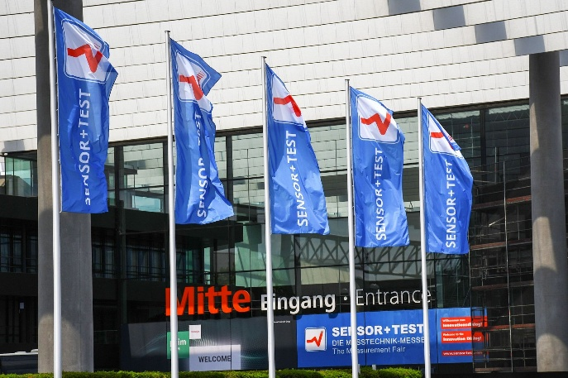

June 1, 2026
Phone: +49 6131 26751-93
presse@sensor-test.com

Press Release

SENSOR+TEST 2026: Sensors, Measurement Technology and Industrial AI Converge into Intelligent Systems

From June 9–11, 2026, Nuremberg will once again become the international meeting point for sensor technology, measurement, and testing technology. SENSOR+TEST expects around 5,000 trade visitors and about 320 exhibitors from around the world, thereby reaffirming its role as the central platform for the industry’s international innovation dialog. The focus is on technological convergence, system integration, and practical knowledge transfer.

SENSOR+TEST 2026 showcases the sensor and measurement technology industry during a phase of profound change. Sensors, data processing, software, and artificial intelligence are increasingly converging into integrated, intelligent complete systems. “We are not witnessing a classic technological leap, but rather a phase of technological convergence,” explains Elena Schultz, Managing Director of AMA Service GmbH. Today, sensors are no longer merely providers of measured values, but central interfaces between the physical and digital worlds. The data foundation is crucial here: “The future of industry is determined not solely by algorithms, but by the quality of the data,” says Elena Schultz. Data quality, synchronization, calibration, and traceability are becoming key factors in industrial value creation.

Focused visibility for sensor technology and measurement technology
At a time when large, broad-based trade shows often overshadow smaller providers, SENSOR+TEST is specifically focused on specialization. Sensor technology, measurement, and testing technology take center stage; visitors will find all relevant innovations in one place – from automotive and mechanical engineering to rail and aerospace.
“Our trade show is in high demand because we offer exhibitors a platform where they are not only seen but also valued,” says Schultz. Trade visitors can efficiently and specifically discover the technologies relevant to them.

Industrial AI: From Trend to Industrial Reality
“Industrial AI” is no longer a topic of the future at SENSOR+TEST 2026, but rather an everyday reality in industry. Sensor technology provides the foundation: precise, structured, and AI-ready data. Applications from predictive maintenance, smart manufacturing, robotics, and data-driven quality assurance will be showcased. The focus is not only on algorithms but also on robust industrial systems. At the same time, edge computing and system integration are gaining importance: data is increasingly processed directly at the source, and decisions are prepared in real time. Sensor technology is thus becoming part of end-to-end digital architectures.
A key trend at SENSOR+TEST 2026 is increasing system integration: Sensors are evolving from individual components into intelligent, networked systems that measure, process, and communicate. Equally crucial is data quality as the foundation of every AI application. Without precise, synchronized, and traceable measurement data, many AI approaches remain theoretical. Multisensor fusion and edge-based data processing are also gaining importance – especially for autonomous systems, robotics, and smart manufacturing.

Knowledge, Exchange and Guidance
A key feature of SENSOR+TEST 2026 is its extensive supporting program, featuring two conferences and a high-caliber expert forum.
The open expert forum offers concise presentations and direct insights into new applications on all three days of the trade show. It is complemented by thematic areas such as Condition Monitoring and Calibration, which specifically create spaces for dialog between manufacturers, researchers, and users. A highlight is the expert forum on “AI-Supported Measurement Technology and Sensor Technology – Intelligent Systems Between Innovation, Responsibility, and Practice,” which focuses on Industrial AI.
Networking is thus actively facilitated – from short presentations to informal encounters in the supporting program. The goal is not to leave networking to chance, but to structure it professionally while keeping it open.

Science and Industry in Direct Dialog
SENSOR+TEST 2026 will once again be accompanied by two conferences: the 23. ITG/GMA-Fachtagung “Sensoren und Messsysteme” and the European Test and Telemetry Conference (ETTC). Here, research, development, and industry come together directly. The topics range from sensor technology and telemetry to IoT, edge computing, and AI, all the way to complex system architectures. The close integration of the conferences and the trade show enables direct knowledge transfer – not only through presentations but also through discussions on the exhibition floor.

Specialization as a Strength
In an increasingly complex trade show landscape, specialization is gaining importance. SENSOR+TEST benefits from its clear focus on sensor technology, measurement, and testing. “Relevance comes from depth, not size,” says Schultz. Visitors find all relevant innovations in one place, while exhibitors reach a highly specialized professional audience.
SENSOR+TEST 2026 showcases an industry in transition: moving away from individual technologies toward integrated, data-driven systems. It is thus far more than a trade fair – it is a strategic hub for sensor technology, industrial AI, and industrial system architectures. “The more complex technologies become, the more important places become where they can be contextualized and further developed collaboratively,” says Elena Schultz. SENSOR+TEST remains precisely this kind of place: a workshop for future technologies – and a central meeting point for industrial transformation.
“We invite the entire industry to actively shape the innovation dialog – on-site in Nuremberg, through direct exchange between industry, research, and development. This is exactly where the momentum arises that turns ideas into concrete applications,” says Elena Schultz, already looking forward to the event.

SENSOR+TEST 2026 will be open from 9 a.m. to 5 p.m. on all three days of the trade show. Visitors can register in advance online at https://www.sensor-test.de/en/visitors/your-exhibition-ticket.

Further information on SENSOR+TEST can be found at www.sensor-test.com.
Upon publication, please provide a copy of the publication or a link.

Press contact:
AMA Service GmbH
Von-Münchhausen-Straße 49, 31515 Wunstorf, Germany

Dirk Schaar
Tel. +49 6131 26751-93, presse@sensor-test.com
Further press releases and photos relating to SENSOR+TEST are available for journalists to download free of charge at www.sensor-test.de/en/press.

Follow SENSOR+TEST on social media:
X: https://x.com/sensorplustest
Facebook: https://www.facebook.com/sensorplustest/
LinkedIn: https://www.linkedin.com/company/sensor-test/

