SENSOR + TEST 2026

DIE MESSTECHNIK - MESSE

The Measurement Fair
9 - 11 June 2026, Nuremberg, Germany

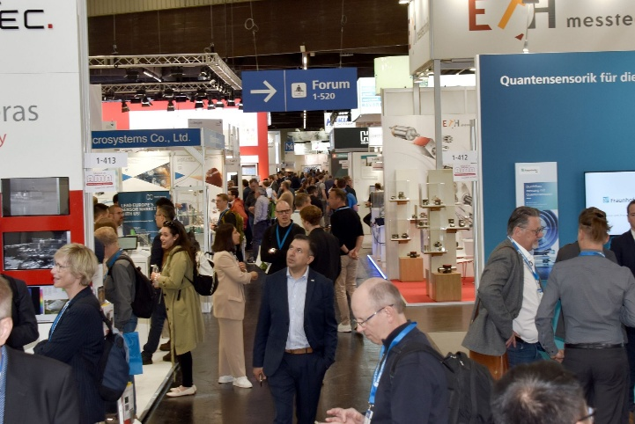

April 30, 2026
Phone:. +49 6131 26751-93
presse@sensor-test.com

Press Release

SENSOR+TEST 2026: A strong supporting program at the industry’s premier gathering place

From June 9 to 11, 2026, Nuremberg will once again become an international hub for sensor, measurement, and testing technology. SENSOR+TEST uniquely combines industrial practice, scientific exchange, and technological innovation - and impresses not only with its exhibitors but also with a comprehensive and high-quality supporting program. With two accompanying conferences, a high-caliber expert forum, including moderated thematic sessions, the trade fair offers an ideal platform for knowledge transfer, networking, and forward-looking inspiration.

SENSOR+TEST 2026 offers its visitors an exceptionally diverse supporting program, which has long been regarded as one of the trade show’s key hallmarks of quality. In 2026, this will once again be complemented by a high-caliber lecture forum in the exhibition. “The quality is very high thanks to the review of submissions by an expert panel, which benefits trade show visitors in particular,” explains Elena Schultz, Managing Director of AMA Service GmbH. “Visitors can look forward to a program that is both substantive and practical.”

Central platform for knowledge transfer and dialog
At the open forum, visitors can gain concise insights into new products, developments, and applications on all three days of the trade show - directly from the source and free of charge. The presentations offer “know-how to go” and make the forum a central communication platform right in the heart of the trade show.
A special highlight is the first day of the trade show: At 12:00 p.m. the presentation of the innovations nominated for the 26th AMA Innovation Award will take place. This will be followed by a high-profile expert forum on the topic “AI-supported measurement technology and sensor technology – Intelligent systems between innovation, responsibility, and practice.” The focus will be on current developments in Industrial AI, new application areas, and challenges such as transparency, standardization, and validation. Representatives from industry and academia will discuss opportunities and limitations - in a practical and forward-looking manner.
“The forum is deliberately designed as an open platform that promotes direct knowledge transfer and strengthens the dialog between exhibitors and visitors. It is precisely the combination of concise presentations, current innovations, and direct exchange that makes this format so valuable for the industry,” emphasizes Elena Schultz.
For those who cannot attend in person: All presentations will be broadcasted live and subsequently made available online.

Key topics with practical relevance: Calibration and Condition Monitoring
With its special sections, the “Calibration Area” and the “Condition Monitoring Area,” SENSOR+TEST 2026 places a focus on two key future topics for the industry - and creates dedicated platforms for experience and dialog that effectively combine exhibition, exchange, and knowledge transfer.
The Innovative Calibration Area presents itself as a modern hotspot for everything related to calibration. An attractive shared booth, and an open forum merge into a vibrant platform where manufacturers, calibration service providers, and users can network directly. The focus is on current and future calibration requirements—from traceability and measurement uncertainty to the International System of Units (SI), digital calibration certificates, and automated processes. Additional insights are provided by the moderated technical presentations in the forum: Here, technological developments are contextualized, best practices are presented, and key industry issues are discussed - in a concise, practical, and to-the-point manner.
The Condition Monitoring Area, as a standalone platform, invites visitors to experience innovative condition monitoring solutions up close. Here, too, the combination of a shared booth, and an open communication area creates a dynamic atmosphere and facilitates direct exchange. The focus is on technologies that make the operation of machines and systems smarter, safer, and more efficient—from retrofit solutions and remote testing to predictive maintenance and AI-supported applications. The “Condition Monitoring” special session, featuring best-practice presentations at the forum, is the ideal platform for the innovation dialog between manufacturers, developers, and users.

Two conferences as a scientific foundation
Running parallel to the trade show, two high-profile conferences underscore the technical expertise of SENSOR+TEST 2026 and specifically expand the program to include a scientific and international perspective. “They bridge the gap between research, development, and industrial application - and make the event a comprehensive industry gathering,” Elena Schultz is convinced.
The European Test and Telemetry Conference (ETTC 2026) is one of the most important international platforms for telemetry, telecontrol, test instrumentation, and data processing, and will once again take place alongside SENSOR+TEST in Nuremberg. The focus is on future-oriented topics such as connectivity, IoT, big data, and wireless communication – more and more in conjunction with artificial intelligence. Telemetry is becoming increasingly important, particularly in data-driven applications: It forms the foundation for autonomous systems, AI-supported analyses, and networked infrastructures - for example, in aerospace, the automotive industry, biomedicine, or UAVs (drones). Topics to be discussed include real-time data processing, edge computing, secure data transmission, and integration into complex, autonomous systems. For the first time, the presentations will be held at the NCC Mitte, which further underscores the conference’s international character and offers significantly improved conditions for speakers and participants.
The conference program is complemented by the 23. ITG/GMA-Fachtagung “Sensoren und Messsysteme 2026”, which has been regarded for decades as the most important German-language scientific event in the field of sensor technology. On June 9 and 10, 2026, renowned experts from research and development will present their latest findings in technical presentations and a poster session. The conference covers a wide range of topics - from sensors for environmental and sustainability applications, through hydrogen technologies and process measurement technology, to safety sensor technology, optical measurement technology, and thermal and gas-sensitive sensors. In addition, current developments in non-contact measurement technology, metrology, and condition monitoring will be highlighted.
For the first time, the scientific leadership is in the hands of Prof. Rupitsch together with Prof. Wöllenstein, both from the University of Freiburg. Together, they are providing impetus for even stronger networking of sensor technology and measurement systems, as well as for their integration into complex industrial applications.

A platform for dialog on innovation and future technologies
SENSOR+TEST positions itself as far more than a traditional trade fair: it is a vibrant platform for dialog where innovations emerge, knowledge is shared, and future technologies are actively shaped. The close integration of exhibition, forum, and conferences creates a unique space for exchange between industry and academia -practical, international, and interdisciplinary.
“SENSOR+TEST thrives on personal dialog and direct exchange among all industry stakeholders. It is precisely this special atmosphere, combined with a substantive supporting program, that makes the trade fair an indispensable meeting place for everyone who wants to actively shape the technological developments of tomorrow,” emphasizes Elena Schultz. “We cordially invite all interested parties to come to Nuremberg from June 9–11, 2026, and become part of this innovation network.”
Tickets for SENSOR+TEST 2026 are available in the online ticket shop (www.sensor-test.de/en/visitors/your-exhibition-ticket). Visitors will thus benefit not only from easy access to the trade show, but also from a comprehensive program full of inspiration, networking opportunities, and new perspectives.
Further information on SENSOR+TEST can be found at www.sensor-test.de.

Upon publication, please provide a copy of the publication or a link.

Press Contact:
AMA Service GmbH
Von-Münchhausen-Straße 49, 31515 Wunstorf, Germany

Dirk Schaar
Phone: +49 6131 26751-93, presse@sensor-test.com
Additional press releases and photos related to SENSOR+TEST are available for journalists to download free of charge at www.sensor-test.com/presse.

Follow SENSOR+TEST on social media:
LinkedIn: https://www.linkedin.com/company/sensor-test/
X: https://x.com/sensorplustest
Facebook: https://www.facebook.com/sensorplustest/

