SENSOR + TEST 2026

DIE MESSTECHNIK - MESSE

The Measurement Fair
9 - 11 June 2026, Nuremberg, Germany

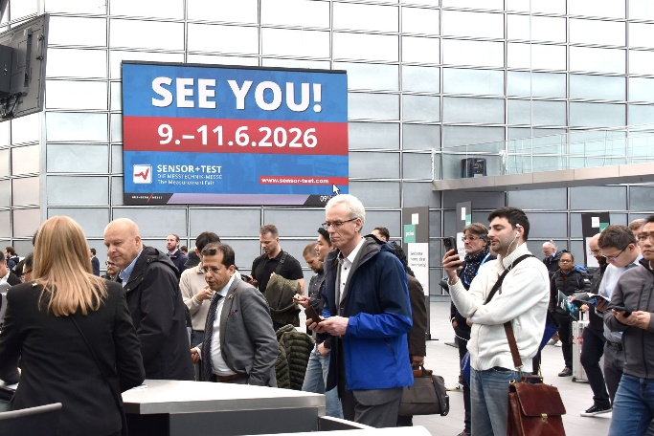

Press release
March 3, 2026
Phone. +49 6131 26751-93
presse@sensor-test.com

SENSOR+TEST 2026: An established platform for innovative sensor and measurement technology

Despite the current difficult economic situation, SENSOR+TEST is maintaining its position as the industry's central platform. From June 9 to 11, 2026, the international trade fair will once again open its doors in Nuremberg, offering manufacturers and trade visitors a stage for innovations, technical discussions, and networking. The organizer expects more than 300 exhibitors from numerous countries to attend again this year, showcasing a wide range of products from sensor technology to AI solutions.
SENSOR+TEST 2026 is impressively defying the current economic situation: even though some of the stand areas are smaller, exhibitors remain loyal to the trade fair. This is because it allows them to present their innovations, engage in direct dialog with trade visitors, and establish valuable contacts for the future.

“The size of the stand is not the decisive factor, but rather the quality of the technology and the professional exchange,” emphasizes Elena Schultz, Managing Director of AMA Service GmbH. Especially in economically challenging times, the trade fair offers a central location for innovation dialog, where manufacturers, users, and scientists come together to jointly advance solutions and set trends. SENSOR+TEST thus demonstrates that, despite all the challenges, the industry is investing, networking, and actively shaping the future. For the first time, the ETTC European Test and Telemetry Conference (https://telemetry-europe.org) will be held in parallel in the conference rooms at NCC Mitte, and the exhibition will take place in hall 1.

Focused visibility for sensor and measurement technology
At a time when large, broad-based trade fairs often overshadow smaller providers, SENSOR+TEST focuses specifically on specialization. Sensor technology, measurement, and testing technology are the main focus, and visitors will find all the relevant innovations in one place - from automotive and mechanical engineering to rail and aerospace.
“Our trade fair is in high demand because we offer exhibitors a platform where they are not only seen but also valued,” says Schultz. Trade visitors can efficiently and specifically discover the technologies that are relevant to them.

Joint booths and cost-effective presentation
The trade fair offers smaller and young companies in particular the opportunity to present themselves effectively on a limited budget. Thematically grouped joint stands allow for a wide reach while reducing costs.
The Federal Ministry for Economic Affairs and Energy (BMWE) supports the participation of young German companies by covering up to 60% of the costs for a booth at the “Young Innovators” joint booth. In addition, there are specialized areas such as the Calibration Area and the Condition Monitoring Area.
SENSOR+TEST offers individually tailored participation packages, such as the technology boxes, which enable small companies, start-ups, and research teams to have an uncomplicated and cost-effective presence at the trade fair. “With our technology boxes, you avoid cost risks and pre-fair stress – you arrive, unpack your equipment, and you're done!” says Elena Schultz, explaining the concept.

Sensors, measurement technology, and AI as key technologies
Sensors and measurement technology form the basis for artificial intelligence in industry – without precise measurement data, intelligent automation cannot function. At SENSOR+TEST, this is evident in a wide range of applications: companies demonstrate how their sensors, measurement systems, and testing technologies act as “data suppliers” for industrial AI solutions and make processes more efficient, safer, and more economical.
AI in industry means much more than large language models. It is about industry-ready systems that work in practice – in self-learning robots, in predictive maintenance, in simulation-based development, or in intelligent production control. So-called “industrial AI” not only enables the optimization of processes and resource utilization, but also opens up new data-based business models and strengthens cooperation between companies, research, and technology providers.
“At SENSOR+TEST 2026, the important role of our industry will become tangible: exhibitors will present practical solutions, innovative systems, and concrete application examples that show how sensor and measurement technology will drive the AI of the future,” says Elena Schultz. Visitors can experience how the intelligent combination of measurement data and AI will enable the next level of automation.

Two parallel conferences: knowledge transfer at the highest level
Two renowned conferences will be held in parallel with the trade fair:
- The 23. ITG/GMA-Fachtagung Sensoren und Messsyssteme 2026 will address current developments in sensor technology, measurement technology, and multi-sensor technology. The conference is aimed at developers, engineers, and scientists and will highlight new fields of application and the analysis of complex measurement systems.
- The ETTC European Test and Telemetry Conference, held for the first time at the Convention Center Mitte, offers an international platform for telemetry, test instrumentation, and data processing. Participants will learn about the role of modern telemetry technologies in aerospace, automotive, biomedicine, and Industry 4.0 - especially in conjunction with IoT, big data, wireless technologies, and drones (UAVs). “The conference facilities at NCC Mitte significantly improve the conditions for all participants, making the event more transparent and comfortable,” says Elena Schultz.
Both conferences promote professional exchange and knowledge transfer between industry and science at the highest level.

Innovation and practical relevance
Other highlights include the Calibration Area and the Condition Monitoring Area, which present state-of-the-art calibration methods, digital solutions, and predictive maintenance systems in a practical setting. “Condition monitoring is no longer a topic for the future, but a decisive competitive factor,” emphasizes Elena Schultz.
The combination of trade exhibition and conferences makes SENSOR+TEST the central meeting place for the industry. Nuremberg impresses with its excellent infrastructure and Franconian hospitality. Elena Schultz: "By focusing on sensor technology and measurement and testing technology, we offer exhibitors and visitors unique added value. We look forward to welcoming numerous trade visitors from Germany and abroad again in 2026."

Further information on SENSOR+TEST can be found at www.sensor-test.com.
Upon publication, we request a copy of the publication or a link.

Press contact:
AMA Service GmbH
Von-Münchhausen-Straße 49, 31515 Wunstorf, Germany

Dirk Schaar
Tel. +49 6131 26751-93, presse@sensor-test.com
Further press releases and photos relating to SENSOR+TEST are available for journalists to download free of charge at www.sensor-test.de/en/press.

Follow SENSOR+TEST on social media:
X: https://x.com/sensorplustest
Facebook: https://www.facebook.com/sensorplustest/
LinkedIn: https://www.linkedin.com/company/sensor-test/

