# SENSOR + TEST 2023

## DIE MESSTECHNIK – MESSE

## The Measurement Fair

**9 – 11 May 2023**, Nuremberg**,** Germany



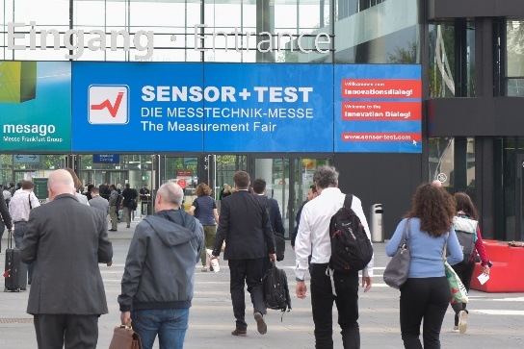

### Press Release

27 April 2023

phone +49 6131 26751-93

presse@sensor-test.com

# SENSOR+TEST 2023:

1. **Innovation dialog continues to gain in attractiveness**
2. **When SENSOR+TEST – the leading international trade fair for sensor, measuring and testing technology – opens its doors again in Nuremberg on Tuesday, 9 May 2023 under the motto "Welcome to the Innovation Dialog!", visitors can expect three days of pure technology with innovations to touch. Until 11 May 2023, around 350 exhibitors will inform visitors and experts from all over the world on site about the trends in the industry. The exhibition will become even more attractive because an exciting supporting programme awaits the audience.**

"Even though we have not yet reached the pre-pandemic figures, there is a clear sign of stability. After we still had to struggle with the uncertainty of the waning Corona period last year, other problems are affecting the markets today. So it will take some time before the general conditions allow growth for industry and trade fairs again and we get back to the figures we had before Corona. But we are counteracting this with many exciting highlights that will make the SENSOR+TEST more attractive", explains Holger Bödeker, organizer and managing director of AMA Service GmbH.

These include, among others, the "Job Lounge", which will take place for the first time. After all, in addition to the skilled workers, the fair is of great importance for the start of a professional career. Numerous university institutes from the relevant fields regularly organize excursions to the SENSOR+TEST. For the exhibiting companies, this is an enormous potential, especially in the current situation. "The fair is the ideal platform for this and we will continue to expand our supporting offers for coping with the shortage of skilled workers in the coming years. We see it as our task to actively mediate and bring together the important players," Elena Schultz, authorised signatory at AMA Service GmbH, is aware.

**SMSI 2023 for the first time as a face-to-face event**

Accompanying the exhibition, the SMSI 2023 - Sensor and Measurement Science International Conference will start on 8 May in the NCC West of NürnbergMesse. The conference brings together national and international representatives from research, science, industry and government institutions. Numerous renowned experts and young ambitious scientists from 14 countries will come together to present their latest research results and exchange ideas and future trends with other experts. "Sensor and measurement technology is highly dependent on innovations from research and development. Their current status will be presented at SMSI 2023. With a strong program of around 250 lectures, tutorials, a science slam and the job lounge, the event already allows a glimpse into the future of our technology," Elena Schultz is pleased to announce. More information is available at www.smsi-conference.com.

1. **Know-how to go in the exhibitor forum**

Another highlight is the lecture program at the Forum in hall 1, which is free of charge for all visitors and takes place on all three days of the fair. Here, the interested visitor can get an overview of the latest products and developments of the exhibitors - virtually in passing. For those interested who cannot be on site, all lectures will be broadcasted live and the recordings will be published online after the event. The series of lectures on "Sensor and Measuring Technology for New Energies" on the first day of the fair deserves special interest. Here, exhibitors will show how they intend to meet the challenges of future energy supply.

**Three fairs complement each other**

This year, the PCIM Europe and SMTconnect trade fairs will again be held at the same time as SENSOR+TEST. The technological combination is intended to increase the added value of a visit and make the joint attractiveness clear.

**Internationally strong again**

Overseas exhibitors were still uncertain last year, but now the international share of the fair is almost back to the level of the years before Corona. China in particular is celebrating a strong comeback, which could have been even better if the visa problems had not been so great. "Nevertheless, about 40% of our exhibitors will come from abroad, a very good figure," says Holger Bödeker.

**Still also digitally on the road**

Even though personal encounters and direct talks are the focus of SENSOR+TEST, the accompanying digital offer will remain. Thus, the live transmission of the forum lectures and the Digital Agenda as an online presentation forum during the exhibition offer information channels for all those who cannot be present in Nuremberg. "Far more important, however, is the provision of the entire information platform with all company contacts, solutions, innovations and presentations, which extends beyond the fair. Thousands of users continuously research suitable suppliers there and find out about their offers," adds Elena Schultz.

SENSOR+TEST 2023 is open from 9 a.m. to 5 p.m. on all three days of the fair. Visitors must register online in advance at https://www.sensor-test.de/en/visitors/exhibition-ticket/. There will be no ticket sales in Nuremberg. However, all exhibitors offer their visitors vouchers for registering for free tickets, so it is worth asking the exhibiting companies in any case.

In case of publication, we ask for a voucher booklet or a link.

***Communication with you as a press representative is very important to us. Therefore, we would like to invite you to the Innovation Dialog during SENSOR+TEST. You do not have a press ticket yet? Then register right away under the following link:***

[***https://www.sensor-test.de/en/press/press-center/accreditation/***](https://www.sensor-test.de/en/press/press-center/accreditation/)

***We would also like to invite you to our new format "Press meets VIP". In short presentations of max. 20 minutes (incl. Q&A session), experts will be available to answer your questions on current topics. A separate invitation will follow in the next few days.***

**Press contact:**

AMA Service GmbH

Von-Münchhausen-Straße 49, 31515 Wunstorf, Germany

Dirk Schaar

phone +49 6131 26751-93, presse@sensor-test.com

Further press texts and photos of the SENSOR+TEST for free download for journalists under [www.sensor-test.de/en/press](http://www.sensor-test.com/presse).

**Follow the SENSOR+TEST also in social media:**

**Twitter:** <https://twitter.com/sensorplustest>

**Facebook:** <https://www.facebook.com/sensorplustest/>

**LinkedIn:** <https://www.linkedin.com/company/sensor-test/>